Sensor Data Service

Installation and IT Admin Guide

Contents

Introduction 2

System Requirements 2

Server PC 2

GPS Device 2

Installation Procedure 3

Step 1: Install Prerequisites – ASP.NET Core Runtime and .NET Desktop Runtime 3

Step 2: Install the Service 4

Step 3: Review server ports and configure firewall rules 4

Step 4: Configure SSL Certificate if you want to use https 5

Step 5: Note the server address 6

System Date and Time 6

Dashboard overview and configuration 7

Home Page 7

Relay Configuration 8

Receiving via Serial Port 8

Receiving via UDP 9

Data Store 9

Cloud Sync Config 10

Plugins 11

Support Requests 11

Locating Error Log Files 11

Erratic mouse movements after plugging in GPS 12

# 

# Introduction

This is the Sensor Data Service Installation and IT Admin Guide. This guide is intended for use by technical staff such as a company IT department.

The Sensor Data Service is an application designed to consume, process and make available historical and real-time GPS positions to other applications through UDP broadcasting and a RESTful API. It is designed to be installed in addition to other applications.

Most set-up is performed from within the application after installation. It is recommended that this is done by IT staff using remote access software such as TeamViewer.

# System Requirements

*See the ‘Installation’ section for further details.*

## Server PC

* Windows PC with Windows versions 8, 10 or 11
* Hardware capable of accepting serial connections (i.e. RS232)
* 4 GB RAM. 10GB hard disk space
* Standard network to connect the clients and server
* .NET Desktop Runtime 8.0 (x86 version)
* ASP.NET Core Runtime 8.0 (x86 version)

## GPS Device

* Capable of outputting NMEA data over a serial connection, **-or-**
* Broadcasting NMEA over UDP.

# Installation Procedure

**NOTE**

Installation of the software requires Administrative permissions on the PC.

Generally the Sensor Data Service should be installed before any other applications that rely on its functionality. The service is installed as a Windows Service. (Using a web server such as IIS is not required or supported.)

Perform the following steps on the PC you will use as the server:

### Step 1: Install Prerequisites – ASP.NET Core Runtime and .NET Desktop Runtime

Install the following prerequisites if they are not already installed on the PC:

* **ASP.NET Core Runtime 8.0** (Windows **x86**)
* **.NET Desktop Runtime 8.0** (Windows **x86**)

The prerequisites are usually supplied along with the Sensor Data Service release. However it is recommended that the latest versions available from Microsoft are used, as these may contain security updates.

The latest 8.0.x versions can be downloaded from this web page:

<https://dotnet.microsoft.com/download/dotnet/8.0>

See the image below – the correct links are highlighted.

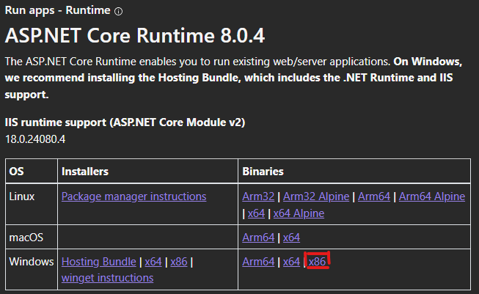

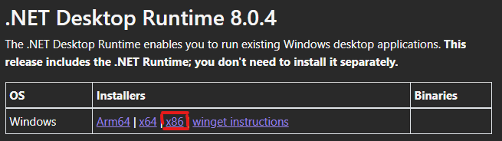

Do not download the x64 version even if the PC is 64 bit, as this will not work – the software is an x86 application.

The latest available versions of the ASP.NET Core Runtime and .NET Desktop Runtime should be used. At the time of writing this is 8.0.4

### Step 2: Install the Service

Double-click the installer file **ChersoftSensorDataService.Setup.msi** to begin the installation, then wait for it to finish.

The Sensor Data Service runs as a Windows service. Type **Services** in the Windows start menu, then run the resulting program, to view the list of installed services. ‘**Chersoft Sensor Data Service**’ will be displayed in the list when successfully installed:   
  
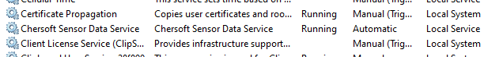

The service runs automatically after install. Confirm it is running by looking at the ‘status’ column.

Right-clicking on the service in this window will give the options to stop, start or restart the application server. This may be required in certain support scenarios.

The service stores data and application logging files at the location **C:\ProgramData\Chersoft\NmeaService** (assuming ‘C:’ is the main drive letter). This includes the GPS tracking history data file. These files will not be removed automatically when the application is uninstalled. Note the folder location is *not* called “ChersoftSensorDataService”, this is because the old name of this application was “NmeaService” so we have retained the name of this folder to allow for ease of upgrading.

### Step 3: Review server ports and configure firewall rules

By default the Service hosts its API and configuration web site on port **5860** (non-SSL) and broadcasts UDP on port **10110** when receiving via serial port.

Any firewalls should be adjusted to allow connections to these ports over the local network.

If you need to change the port numbers due to conflicts or IT policy, this can be done by editing a configuration file. First stop the ‘**Chersoft Sensor Data Service’** Windows service. Then open the following file in a text editor:

C:\Program Files (x86)\Chersoft\  
 Chersoft Sensor Data Service\**appsettings.json**

Edit the highlighted value as required:

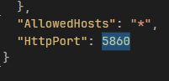

Save the file and restart the Service.

The UDP output is configured through the application dashboard.

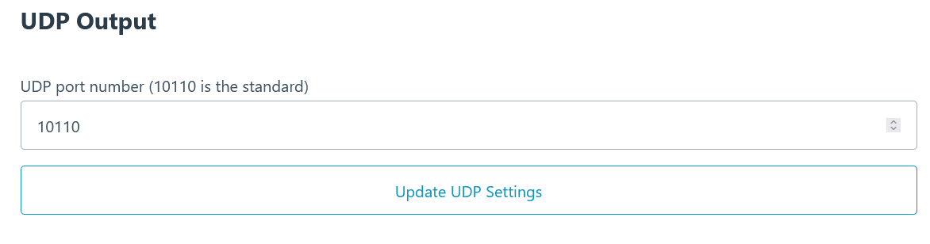

### Step 4: Configure SSL Certificate if you want to use https

To properly configure SSL you will need to create your own certificate and add the desired port to the config.

Put your HttpsPort value in your appsettings.json, along with the kestrel config so it can find your certificate, details of which can be found here:

https://learn.microsoft.com/en-us/aspnet/core/fundamentals/servers/kestrel/endpoints?view=aspnetcore-8.0#configure-https-in-appsettingsjson

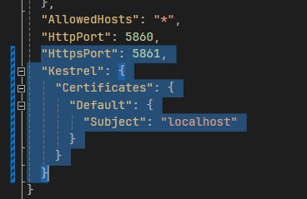

### Step 5: Note the server address

Take note of the name of the server PC. Also note the HTTPS port number if it was changed from the default. This address information must be entered when configuring client applications to connect to the service.

To obtain the PC name, click the Windows Start button and type “PC name”, then click on “View your PC name”:

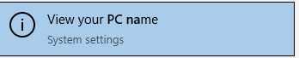The name will be listed under “Device name”.

## System Date and Time

The system clock of all computers – both clients and servers - must be set to the correct date and time. The specific time zone is not important as long as the correct UTC time can be obtained.

# Dashboard overview and configuration

Runtime configuration is done primarily through the service’s web dashboard, assuming there have been no modification to port settings detailed in step 2 of the installation, the dashboard will be accessible via <http://localhost:5860> and <https://localhost:5861>.

Once the dashboard has been reached the different configuration sections can be accessed via links at the top of the page.   


## Home

This section contains a status of all the services within the Sensor Data Service as whole. You will first see the Data Store status, which can be configured by clicking on the Data Store tab at the top, see Data Store section for more info.  
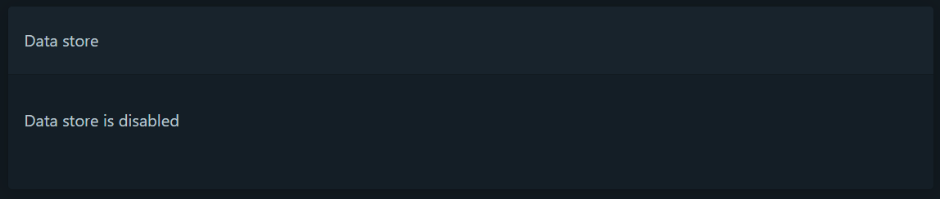  
Then you will see the Service status section. Here you will be able to see which services are working, faulted, waiting, etc. The services that show up here will depend on your config.  
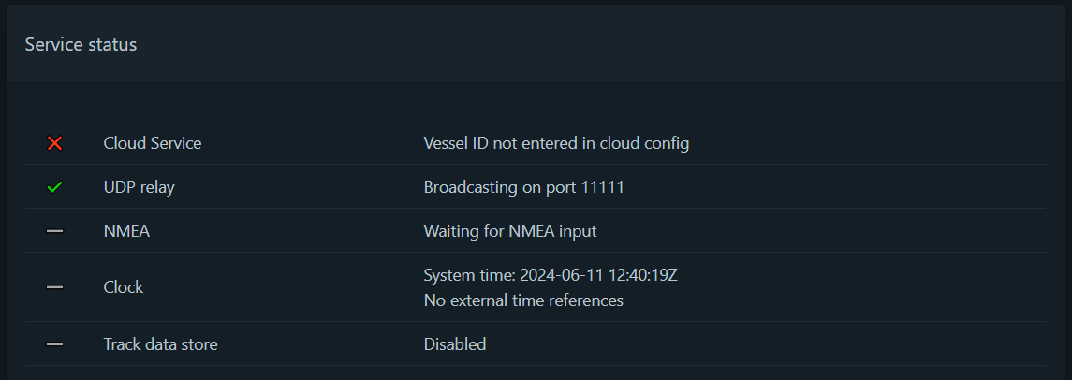

Finally you will see a list of logs, useful if there is an error within any of the services.  
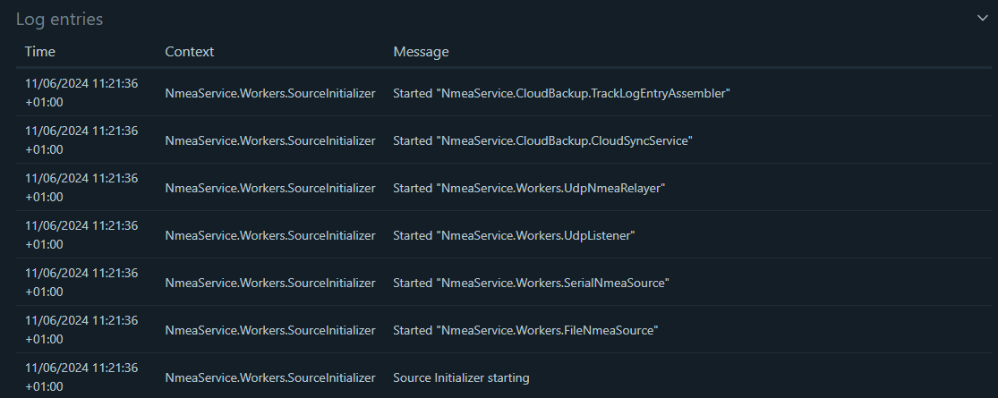

## Relay Configuration

This section concerns the configuration of the NMEA Relay functionality. For the NMEA Relay service to function, the GPS device must be configured. Currently, receiving NMEA via serial port and UDP are supported. You cannot use both at once.

## Receiving via Serial Port

The serial COM port and baud rate for the GPS device must be configured as shown below. Click ‘Use Serial Port’ when done to save settings.

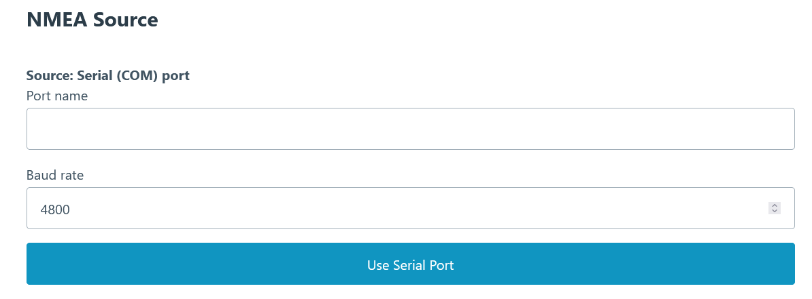

When receiving via serial port, the NMEA is broadcast over UDP. The UDP broadcast port is configurable here if it requires modification. 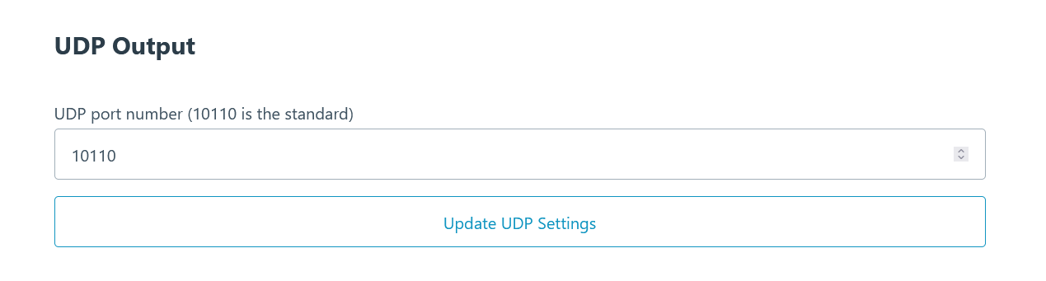

## Receiving via UDP

The UDP receive port number should be configured as shown below. Click “Update UDP Settings” when done to save settings

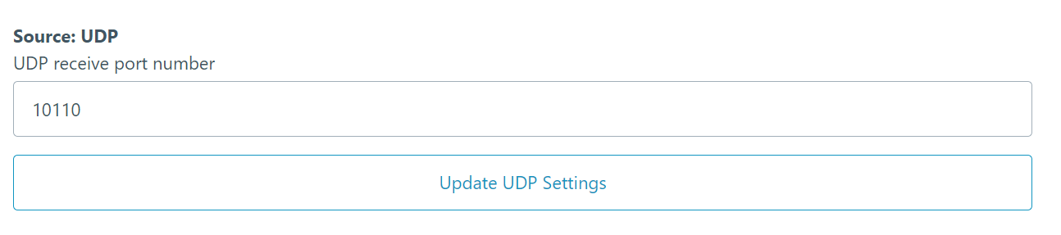

**NOTE**

When configured to receive via UDP, the NMEA Service does not rebroadcast the feed, as this would be redundant.

## Data Store

This section allows for the configuration of the GPS data storage. When this setting is enabled captured GPS data will be stored in a local database file. This setting is required for the API to function correctly.

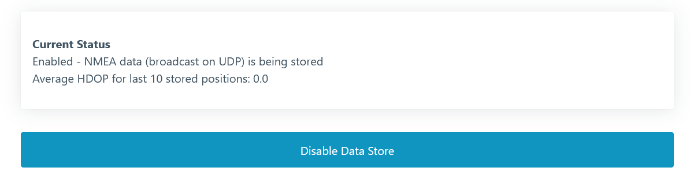

## Cloud Sync Config

This section allows for the configuration of Cloud Sync Service. Please note that you will need to specifically request this from us so we can register your Vessel for the service. Once you have done this, we will provide you with a Vessel ID which you need to enter into the Vessel ID section, and then press the Update Vessel ID button. Then click the “Enable Cloud Sync” button. You may also change the Cloud Sync Interval value if you want to choose how often the Service will attempt to Sync to the Cloud.

# 

# 

# Plugins

If you have requested a specific plugin from Chersoft you will need to add it manually to the Plugins folder:

C:\ProgramData\Chersoft\NmeaService\Plugins

We will have sent you a folder containing the requested plugins, simply unzip the contents of this folder to the Plugins location then restart the service.

# Support Requests

If you are reporting a software error, please also include the most recent application error log files from the client and server applications.

Include as many other details as you can, such as:

* Software version (listed on the Settings – Support tab in the client application)
* Windows operating system version
* What GPS Device is being used and it’s status
* Whether the error occurred just once or every time you perform an action
* What action you were performing at the time the error occurred, and just before this
* Whether the error occurs on just one computer or several.

## Locating Error Log Files

These are located on the server PC in a location similar to:

C:\ProgramData\CherSoft\NmeaService\AppLogs

## Erratic mouse movements after plugging in GPS

Windows can sometimes misinterpret a connected GPS device as a mouse. This makes it hard to use the computer until the registry is changed to stop this.

Change the following registry key:

HKEY_LOCAL_MACHINE\SYSTEM\CurrentControlSet\Services\sermouse

Set the value of “Start” to be 4

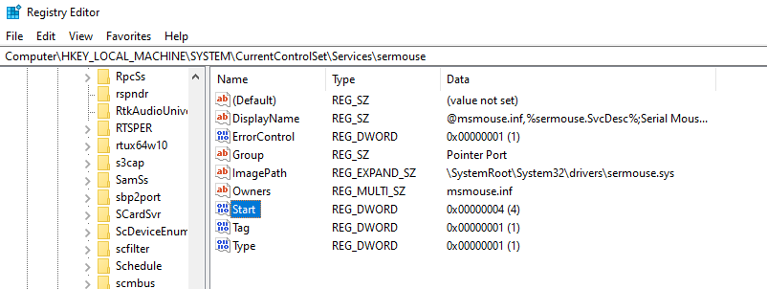

***CHERSOFT, 14 June 2024.***